**Airbnb ETL flow Demonstration**

1. Activate your virtual environment(always recommended in local)

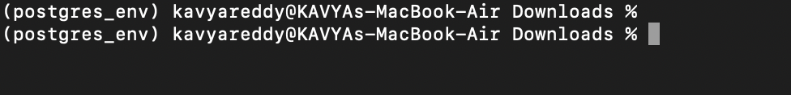

1. Start to run the flow using python3



1. Workflow starts running

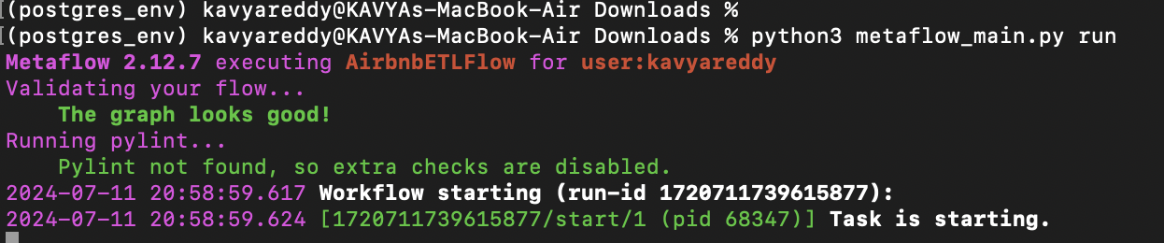

1. Each step is executed in the following way!

